Managing Linux Services

1. **Setting Up the Environment:**

- create a virtual machine (VM) in ubuntu.
- Ensure your system is up to date using the package manager relevant to your distribution.

- sudo apt update
- sudo apt upgrade

Install software

- sudo apt install nginx

2. **Service Basics:**

- To list all services : “sudo systemctl list-units –type=service”.

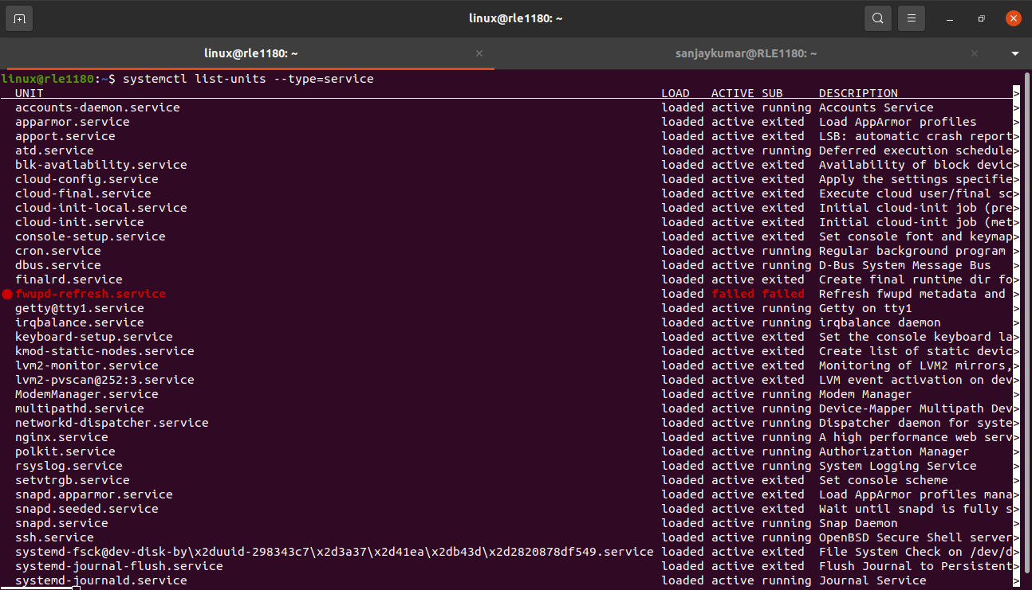
2. To start the service : “sudo systemctl start <service_name>”.
Ex : “sudo systemctl start nginx”.
3. To stop the service : “sudo systemctl stop <service_name>”.
Ex : “sudo systemctl stop nginx”
4. To enable a service to start at boot : “sudo systemctl enable <service_name>”.
Ex : “sudo systemctl enable nginx”.
5. To disable a service from starting at boot : “sudo systemctl disable <service_name>”.
Ex : “sudo systemctl disable nginx”.
6. To check the status of a service : “sudo systemctl status <service_name>”.
Ex: “sudo systemctl status nginx”.
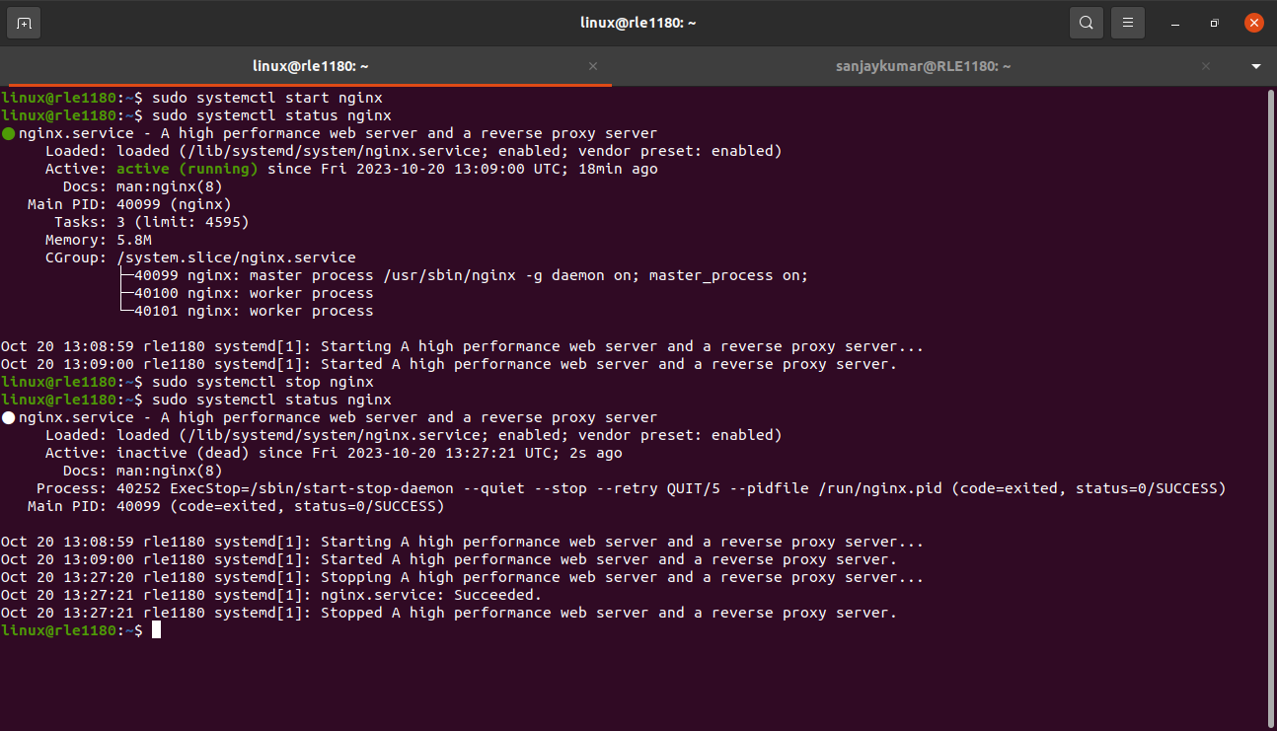
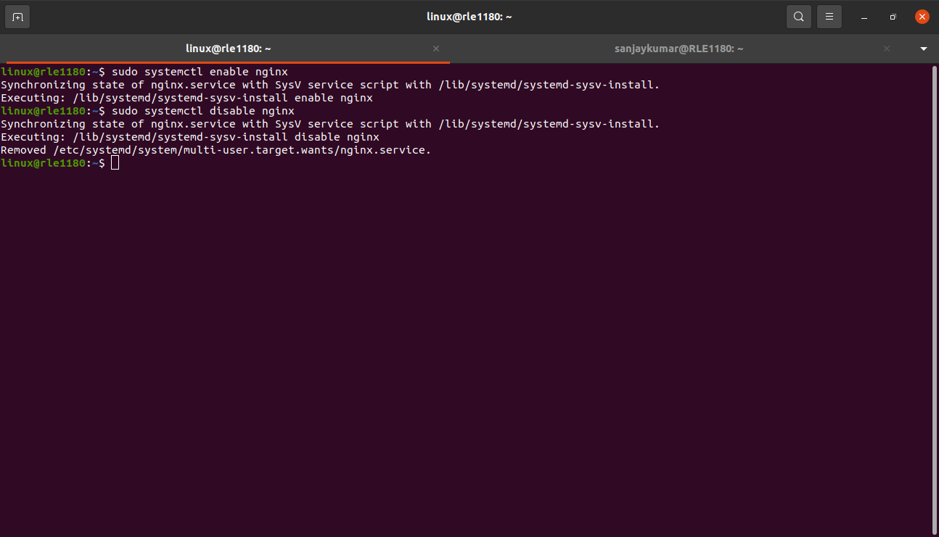

3. **Service Configuration:**

- Explore the nginx configuration file

- open the nginx configuration file using nano.
Ex : sudo nano /etc/nginx/nginx.conf

The configuration file to find settings you want to modify,such as the default port,server blocks or logging configurations.

2. Make changes to the configuration file

- let’s change the default port nginx listens on from 110 to 8080.
listen 110 change it to listen 8080

3. Test the Configuration

- befor applying the changes,check syntax errors.
Ex : sudo nginx -t

4. Reload and Restart nginx

- to reload nginx without stopping active connection
Ex : sudo systemctl reload nginx
- to restart nginx
Ex : sudo systemctl restart nginx
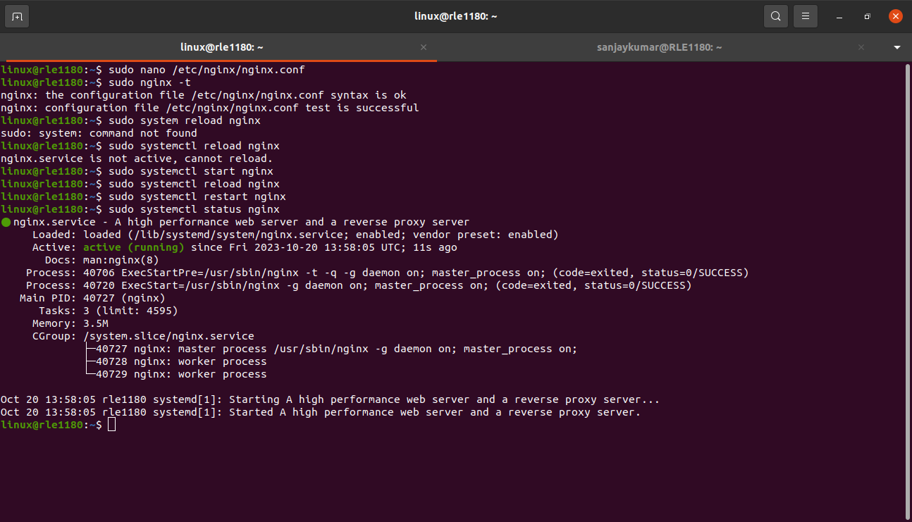

4. **Creating Custom Services:**
- Create a simple custom service unit file in `/etc/systemd/system/` (e.g., `my-service.service`).

1. create a custom service unit file

Ex : sudo nano /etc/systemd/system/my-service.service

- Write a script that simulates a basic service (e.g., a script that prints a message to the console).

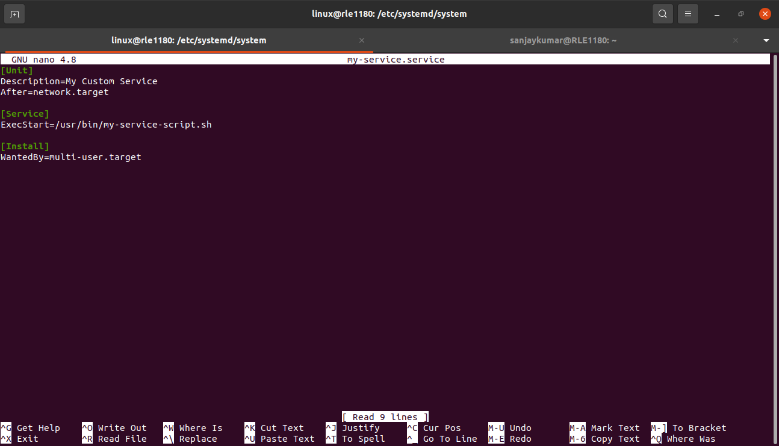

2. write a simulated service script

- create the script that will be executed by the service.
Ex : create the script /usr/bin/my-service-script.sh

sudo nano /usr/bin/my-service-script.sh

add the following content to the script:

#!/bin/bash
echo “hello,world!”

make the script executable.

sudo chmod +x /usr/bin/my-service-script.sh

- Enable and start your custom service.

- sudo systemctl enable my-service.
- sudo systemctl start my-service .

- Verify that it runs successfully using `systemctl`.

- Sudo systemctl status my-service.
- To display the log output from your custom service.

- Journalctl -u my-service.

